**LAB 4: Jets, Ice Cream, and Steam Implosions**

Ratthamnoon Prakitpong - 63205165

Hamayun Aziz - 62064167

Arjun Vadehra - 20037164

Section A

Lab Date: March 2nd, 2018

**Summary**

The purpose of this experiment is to understand the momentum equation and understand how thermodynamics play a role in making ice cream and can implosions. Part A of the experiment required us to direct a jet of air through a nozzle and measure the force acting on the plate which varied with pressure and various angles. Part B of the experiment was observing how salt can lower the melting point of ice to about -7 °C which allows milk with ice cream contents to solidify steadily. Finally we saw how suddenly reducing the pressure of a can with boiling water and restricting its opening can cause the can to implode.

**Procedures**

See Mech 222 Lab manual

**Results and Calculations**

**Part A:**

|  |  |  |  |  |
| --- | --- | --- | --- | --- |
| Trial (#) | Pressure (psi) | Angle (deg) | Height (mm) | Force (g) |
| 1 (reference) | 80 | 90 | 55 | 340 |
| 2 | 40 | 90 | 55 | 233 |
| 3 | 20 | 90 | 55 | 48 |
| 4 | 80 | 67.5 | 55 | 306 |
| 5 | 80 | 45 | 55 | 205 |
| 6 | 80 | 90 | 70 | 333 |

*Table 1: Measured forces corresponding to pressure, angle, and height*

*Note: While forces are not usually presented in grams, the force measuring apparatus is a scale (F = mg). However, due to the qualitative nature of this lab, a precise number is not needed and F = mg calculation will be skipped for simplicity.*

|  |  |
| --- | --- |
| Constant(s) and equation(s) |  |
| Nozzle diameter (in) | 0.145 |
| Air density (kg/m^3) | 1.225 |
| Downward force, combining equation 12 & 14 from prelab (N) | -(Preservoir)(C^2)(Anozzle)sin(theta) |

*Table 2: Relevant measurements*

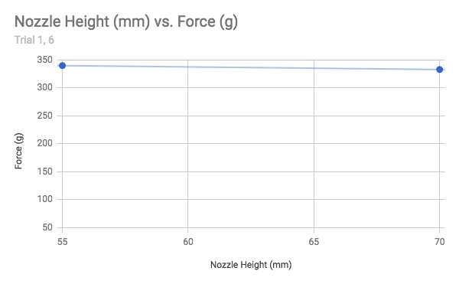

*Figure 1: Nozzle height (mm) vs Force (g)*

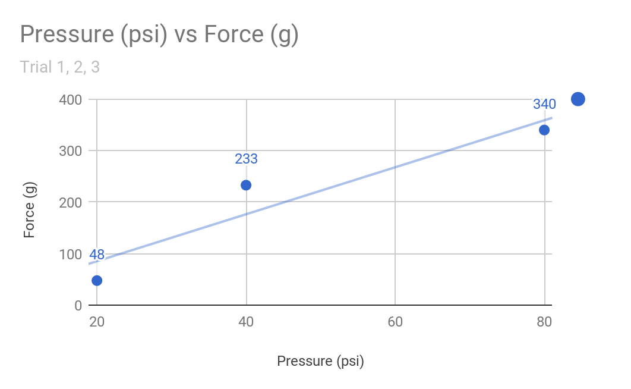

*Figure 2: Pressure (psi) vs. Force (g)*

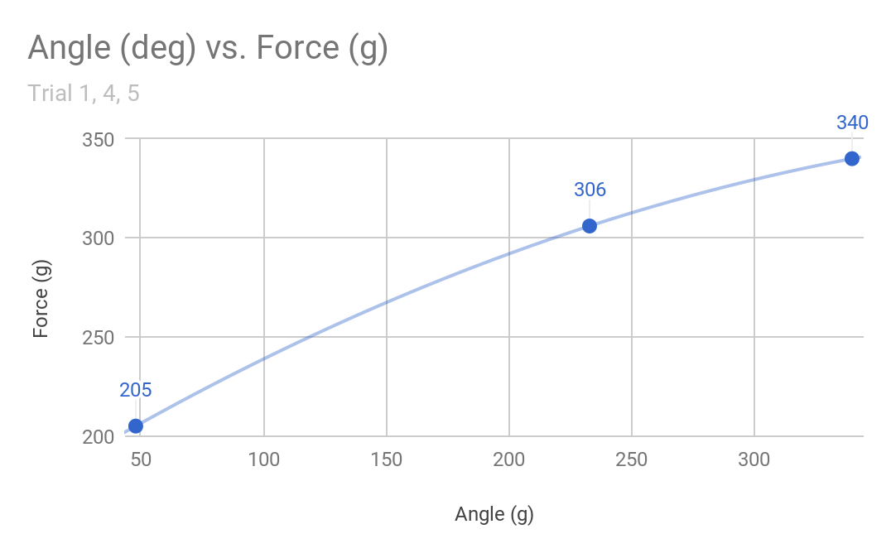

*Figure 3: Angle (deg) vs. Force (g)*

**Part B**

|  |  |  |
| --- | --- | --- |
| **Time** | **Ice cream + salt temp** | **Description** |
| 0 | 7.5 | Normal milk. still liquid |
| 10 | -0.8 | Liquid remains |
| 20 | -1.2 | Liquid remains |
| 30 | -3 | Partial solidification |
| 40 | -2 | Solidified |

**Part A**

1. **Describe how the force exerted by the air jet varies with the distance of the nozzle above the plate. Explain this behaviour.**

According to Figure 1 being an approximately horizontal slope, there is no correlation between nozzle height and force output. Looking at the force equation from Table 2, this makes sense because the force is not dependent on nozzle height.

1. **Describe how the force on the plate varies with reservoir pressure and compare with theory.**

According to Figure 2 being an approximately linear slope, there is a linear correlation between reservoir pressure and force output. Looking at the force equation from Table 2, this makes sense because the force is linearly dependent on the reservoir pressure *(Preservoir).*

1. **Describe how the force on the plate depends on the angle between the jet and plate and compare with theory.**

According to Figure 3 being an approximately curved slope, there is trigonometric correlation between reservoir pressure and force output. Looking at the force equation from Table 2, this makes sense because the force is dependent on the sin of angle *(sin(theta)).*

**Part B**

Questions

1. Adding salt to ice forces a phase change. Which equilibrium is shifted, and in what way it shifted?

Ans: The solid-liquid phase equilibrium is shifted in the direction of the liquid since the addition of salt decreases the freezing point of water.

2) Does transforming solid into liquid require an energy input, or produce an energy output?   
Ans: Transforming a solid into liquid is achieved by the breaking of intermolecular bonds which requires an energy input.

3) Assuming that the rate of heat transfer is very small, where does the energy input/output come from/go to? The distinction between sensible internal energy and latent internal energy may be helpful to you.

Ans: The energy input comes from the surroundings around the ice. The outside is considered to be insulated (due to towel). Hence the only energy input is the milk and its content. The salt and ice form a partial liquid region with a lower melting point causing the temperature gradient to increase between the ice cream and the ice. This increase in the temperature gradient causes the energy input going from the ice cream to the ice and is used up to break intermolecular bonds in the ice (thereby reducing ice cream’s temperature).

4) Where are the heat fluxes? In which directions do they flow? Considering that the goal is to freeze milk into ice cream, which heat fluxes are you trying to minimize, and which ones are you trying to maximize?

Ans: The two heat fluxes are:

1. Between the ice and the surroundings
2. Between the ice and the milk packet

We are trying to reduce the heat flux between the ice and the surroundings by wrapping it in a towel. We are trying to maximise the heat flux between the ice and the milk.

**Part C**

Questions

Describe the mechanism of the can implosion that can explain your experiments. Specifically,

1. Consider a control mass consisting of the steam/water in the can at the instant that the can is placed in the water pool.
2. What happens to the temperature, pressure, quality and energy of this system?
3. The momentum equation from fluid mechanics is also involved – explain how.

Explanation for the can implosion:

Initially, we fill the can with some water and heat it so that the water in the can starts boiling. Note that the control volume of this experiment is the region inside the can. So once boiling begins, the can is in the saturated liquid/vapor phase, which means that there is both water and vapor inside the can. If we keep heating the can, the quality of the saturated mixture increases, which means that the vapor inside the can increases.

When we put the can upside down in ice water with a low temperature, energy is drawn out of the system. This causes the quality of the saturated mixture to decrease. This means that the more of the steam turns back to water. Since the steam condenses and quality is lower, this causes a low pressure inside the can relative to the atmospheric pressure. This pressure differential causes the can to crush or implode.

It should also be noted that this implosion happens due to the opening of the can being small. If the opening was large enough, the ice water would have been pushed up the can like a manometer to account for the pressure difference. However, since the can opening is small, to account for the pressure difference, the can is crushed.

At the end of the experiment when we were trying to take the can out of the water we noticed that there was a certain force pushing the can down. Once we took the can out , water was coming out of the can. This meant that water was pushed up the can, like a manometer due to the vacuum being created inside.

Since there was a vacuum inside, due to the pressure difference, water enters the can. This means that water is entering our control volume at a particular velocity, density and through a certain area. If we look at the momentum equation: 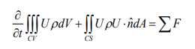

The first part of the equation is zero since the flow can be assumed to be steady. So the equation becomes: 

So the water moving across the control surface into the can causes a force on the can acting downwards.